Name :
Haseeb ur Rehman
Roll No :
SU92-BSSEM-F25-138
Section :
BSSE-2C

Programming Fundamentals (Theory)

Assignment-4

Question 1: CREATE Operation

Write a C++ program that creates a new file named students.txt and writes the records of 5 students into it. Each record should contain the Roll No, Name, and Marks of a student, taken as input from the user at run time. Use the ofstream class and the appropriate file-opening mode to create the file.

CODE

#include <iostream>
#include <fstream>
#include <string>
using namespace std;

int main() {
// Declaring and opening file in output mode
ofstream outFile("students.txt");

// Checking if file opened successfully
if (!outFile.is_open()) {
cout << "Error: could not create file!" << endl;
return 1;
}

int roll;
string name;
float marks;

for (int i = 1; i <= 5; i++) {
cout << "Enter details of Student " << i << endl;

cout << "Roll No: ";
cin >> roll;

cout << "Name: ";
cin.ignore();
getline(cin, name);

cout << "Marks: ";
cin >> marks;

// Saving data to file
outFile << roll << " " << name << " " << marks << endl;
}

// Closing the file
outFile.close();
cout << "Records saved successfully." << endl;
return 0;
}

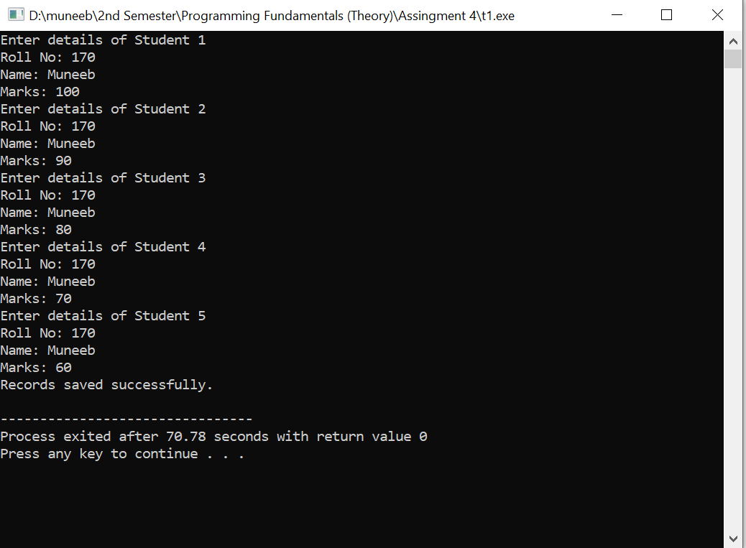

Question 2: READ (Display) Operation

Write a C++ program that opens the students.txt file created in Question 1 and reads its contents back into the program. The program should display all student records on the console in a neatly formatted table, and also display the total number of records found in the file.

CODE

#include <iostream>
#include <fstream>
using namespace std;

int main() {
// Opening file in input mode
ifstream inFile("students.txt");

// Checking if file opened successfully
if (!inFile.is_open()) {
cout << "Error: file not found!" << endl;
return 1;
}

int roll, count = 0;
string name;
float marks;

cout << "Roll\tName\tMarks" << endl;

// Viewing data from file
while (inFile >> roll >> name >> marks) {
cout << roll << "\t" << name << "\t" << marks << endl;
count++;
}

// Closing the file
inFile.close();
cout << "Total records: " << count << endl;
return 0;
}

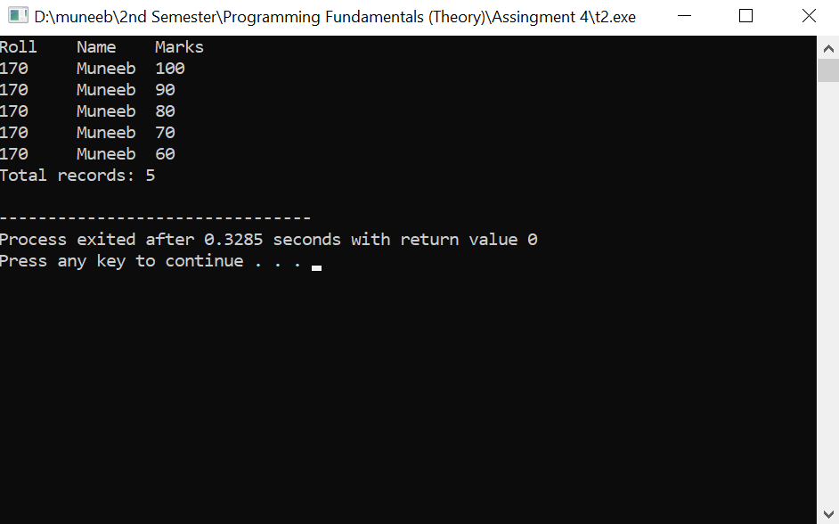

Question 3: UPDATE Operation

Write a C++ program that updates the Marks of a specific student in students.txt. The program should ask the user for a Roll No, search the file for a matching record, and update only that student's marks with a new value entered by the user — without disturbing the other records.

CODE

#include <iostream>
#include <fstream>
#include <iomanip>
using namespace std;

int main() {
// Opening file for both reading and writing
fstream file("students.txt", ios::in | ios::out);

// Checking if file opened successfully
if (!file.is_open()) {
cout << "Error: file not found!" << endl;
return 1;
}

int searchRoll, roll;
string name;
float marks;
float newMarks;
cout << "Enter Roll No to update: ";
cin >> searchRoll;
cout << "Enter new Marks: ";
cin >> newMarks;

bool found = false;

// Reads file record by record
while (file >> roll >> name >> marks) {

//Checking the Roll No
if (roll == searchRoll)
{
found = true;

// Move write pointer to the marks position
file.seekp(-3, ios::cur);

// Write new marks
file << newMarks;

break;
}
}

//Closing file
file.close();

//Checking if Roll No found or not
cout << (found ? "Record updated successfully."
: "Roll No not found.") << endl;
return 0;
}
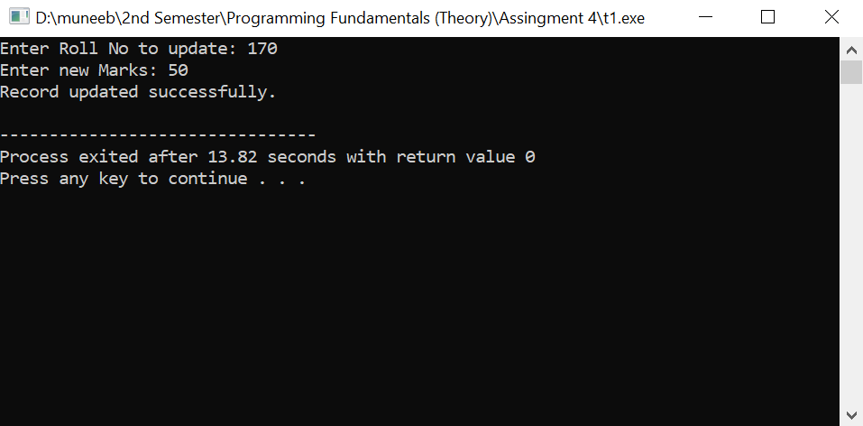
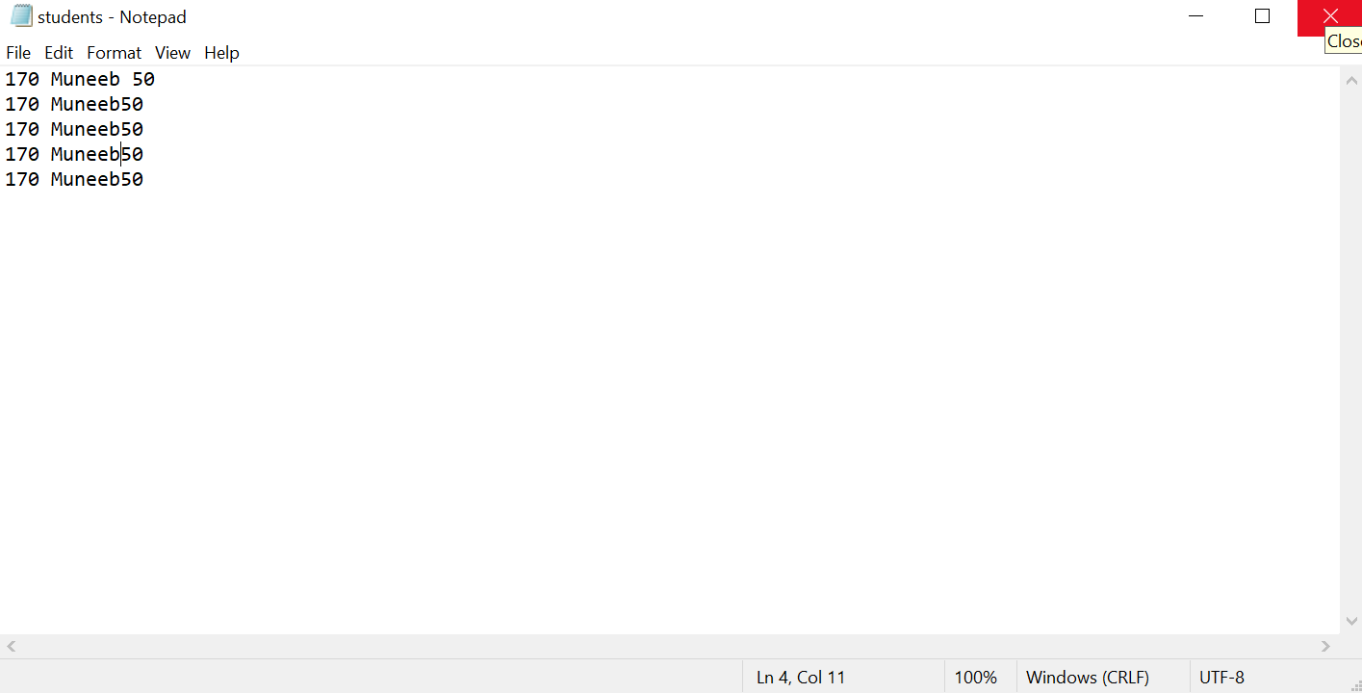

Question 4: DELETE Operation

Write a C++ program that deletes a specific student's record from students.txt, given the Roll No entered by the user. Since C++ file streams cannot remove a line from the middle of a file directly, use the temporary-file technique: copy every record except the one to be deleted into a new temporary file, then replace the original file with the temporary file.

CODE

#include <iostream>
#include <fstream>
#include <cstdio>

using namespace std;

int main()
{
// Opening the original students.txt file for reading
ifstream inFile("students.txt");

// Creating a temporary file to store records that will not be deleted
ofstream tempFile("temp.txt");

// Checking if both files opened successfully
if (!inFile.is_open() || !tempFile.is_open())
{
cout << "Error opening files!" << endl;
return 1;
}

int searchRoll;
int roll;
string name;
float marks;

cout << "Enter Roll No to delete: ";
cin >> searchRoll;

bool found = false;

// Reading every student record from students.txt
while (inFile >> roll >> name >> marks)
{
// Check if current record matches the Roll No to be deleted
if (roll == searchRoll)
{
found = true;

// Skiping writing this record and moving to the next record
continue;
}

// Copy all records except the deleted one
tempFile << roll << " "
<< name << " "
<< marks << endl;
}

// Closing both files after reading and writing is complete
inFile.close();
tempFile.close();

// Deleting the original students.txt file
remove("students.txt");

// Rename temp.txt to students.txt now the temporary file becomes the original file
rename("temp.txt", "students.txt");

// Displaying if record was deleaded or not
cout << (found ? "Record deleted successfully." : "Roll No not found.") << endl;

return 0;
}

